**Exercise 4: Windows problem solving**

Please connect with an rdp client to the following machine as mentioned in the intro.

We have an issue with the web application installed. When browsing to http://localhost/ we get

a 503 exception. Please diagnose and solve the issue.

Please deliver:

● A short description of your troubleshooting process.

● Tell us what's wrong

● Explain what you did to fix it

We will validate the machine and check if the web application is running now.

**Solutions:**

**Troubleshooting Steps:**

1. Login into server and check the web service status using the browser
2. Validate the System Event Log to gather the information about the 503 failure on web server
3. Open the IIS Manager and check the status of the application
4. Restart the IIS service and check the System Event Log
5. Check the Application pools in IIS Manager

**Problem:**

When I check the System Event log file. There was not much information about the Web service failure and 503 error. I have tried to restart the IIS service and it’s failed to start. Then I have checked the System Event Logs, which says **“Application pool DefaultAppPool has been disabled. Windows Process Activation Service (WAS) encountered a failure when it started a worker process to serve the application pool.”** DefaultAppPool is failed to start and causing the issue web service failure.

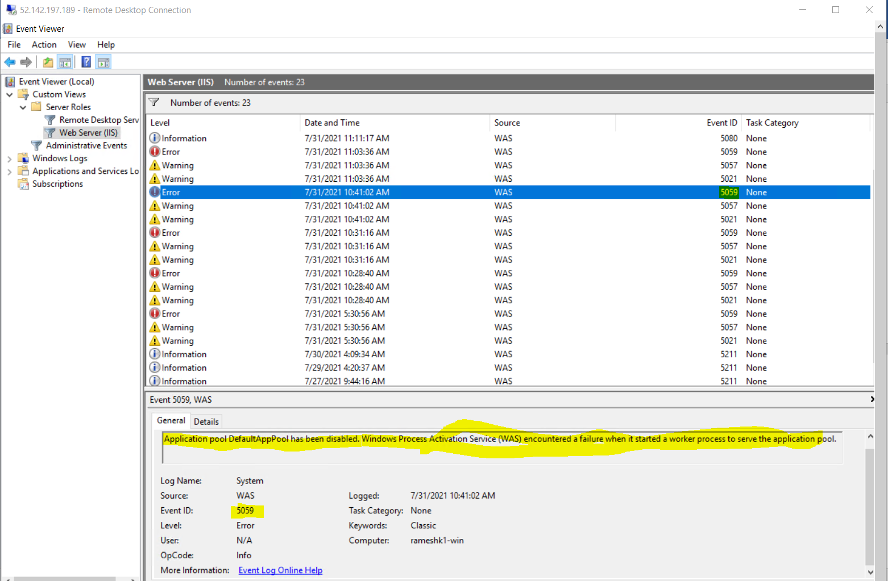

**Fixes:**

I have checked the DefaultAppPool **Identity** and found it associated with ApplicationpoolIdentity and changed the identity to NetworkService. Started the DefaultAppPool service and restarted the IIS server, this time service has been started and web application also came to online. 